Title of the communication (style “Title”)
Presenting Author,a John F. Smith b (Style “Authors”)
ª Affiliation 1 (Style “Affiliations”)
^{b} Affiliation 2. Please do not use “a” in the author list if there is only one affiliation
This is the main text of the abstract (style “Main text”), which must be written in English. Please do not exceed 1 page. No abstracts will be accepted that include presenting authors who do not register to attend the SP8 conference. Each participant can submit up to two abstracts as presenting author. Additional abstracts will be charged with an additional fee of 40 € per abstract. Only one abstract can be selected for oral communication per presenting author.
Please do not modify the template format. It is important to follow strictly the format of this document, using the styles included. We strongly recommend typing the abstract over this template in order to ensure that all contributions have the same format in the book of abstracts. To insert superscript, subscript, bold, italic or underlined characters please use the appropriate Word style (i.e. “Superscript”, “Subscript”, “Bold”, “Italic”, “Underlined” in the Styles box).
Abstracts must be uploaded through the abstract submission area on the website https://sp8.unistra.fr/. Please, read the instructions carefully. If you have any technical problem with the abstract submission, please contact sp8-contact@unistra.fr. Abstracts should be submitted only in MS Word format or any compatible file formats. Abstracts in PDF or image formats will not be accepted. Remember you must choose one of the following topics in the submission procedure:
Solar to electricity conversion
Air and water remediation
Solar fuels
Organic synthesis and solar chemicals
Modelling and mechanistic studies
Chemical engineering
New materials
Operando/in-situ characterization
Commercial applications and standardization
Functionalized and self-cleaning surfaces
Others

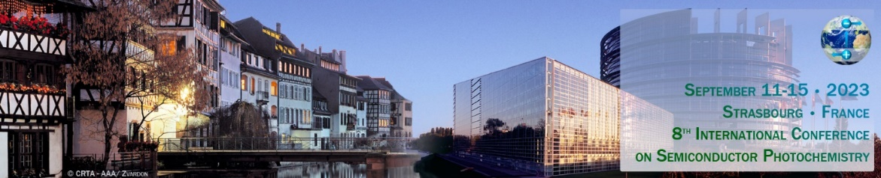
Fig. 1. Style “Figure caption”.
References and acknowledgements should appear at the end of the abstract. References should be sequentially numbered with square brackets before punctuation mark. Please follow the examples below for articles in journals [1], conference proceedings [2], books [3] and book chapters [4], using the style “References”.
The file should be named as “Surname_Name_X.docx”, corresponding to the presenting author, where X is the number of the abstract submitted by the same presenting author (as in Smith_John_1.docx).
References
[1] X. Author, Y. Author, Z. Author, J. Appl. Photochem. 11 (2023) 151.
[2] X. Author, Y. Author, Z. Author, Proc. of the 8th International Conference on Semiconductor Photochemistry, Strasbourg, France, 2023, pp. 10-12.
[3] Semiconductor Photochemistry. X. Editor, Y. Editor, Z. Editor (Eds.), Publisher, Strasbourg, 2023.
[4] X. Author, Y. Author, in Semiconductor Photochemistry, X. Editor, Y. Editor (Eds.), Publisher, Strasbourg, 2023, pp. 10-31.
Acknowledgements
Style “Acknowledgements”. This work has received financial support from the International Funding Agency.

